MAJOR PROJECT

NAME: K.V SRAVAN KUMAR

COLLEGE: SRM UNIVERSITY, RAMAPURAM

BRANCH: CSE-AIML

YEAR: 3RD YEAR

DEGREE: B.TECH

PHONE.NO: 9392769066

MAIL ID: [kotamarthysravan2002@gmail.com](mailto:kotamarthysravan2002@gmail.com)

**MAJOR PROJECT 1**

Choose any dataset of your choice and apply a suitable CLASSIFIER/REGRESSOR .

PROCEDURE:

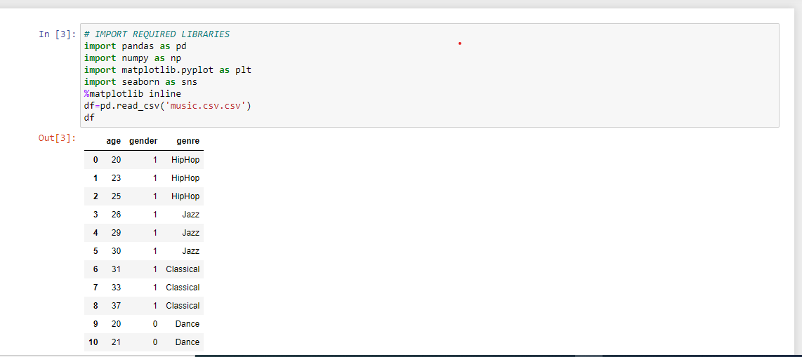

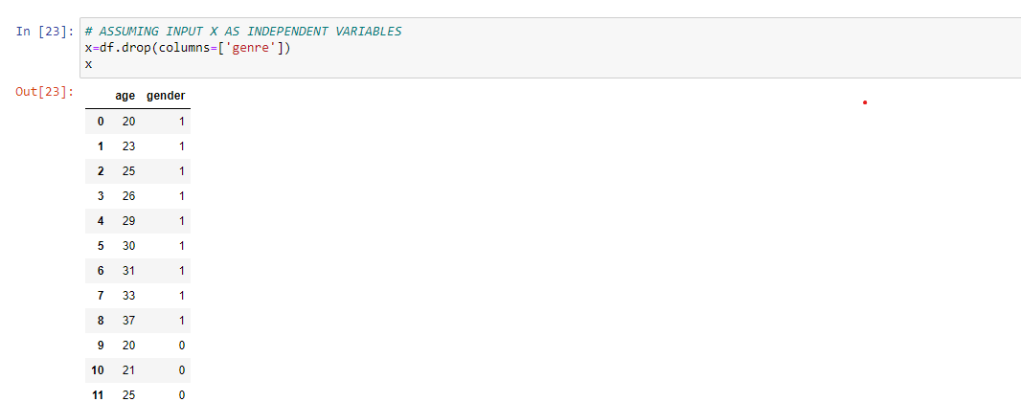

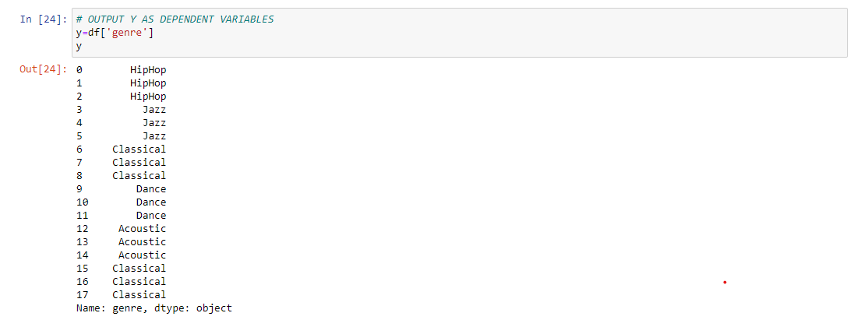

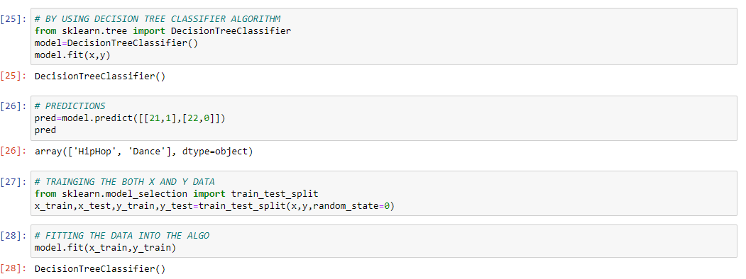

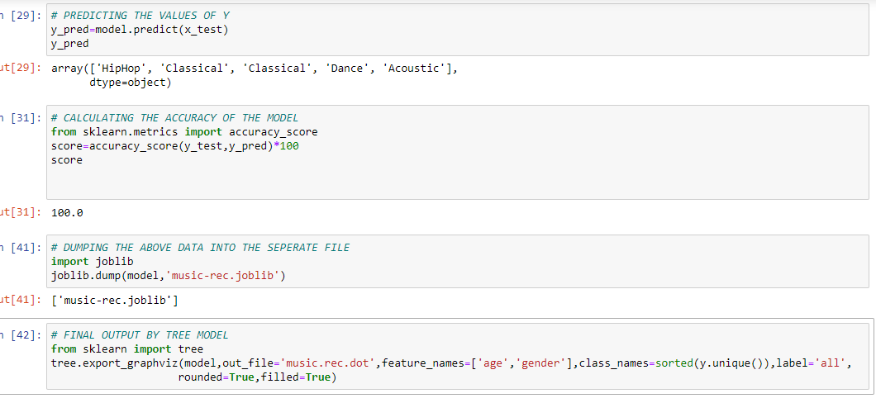

By opening the separate music.rec.dot file we get the below .DOT code

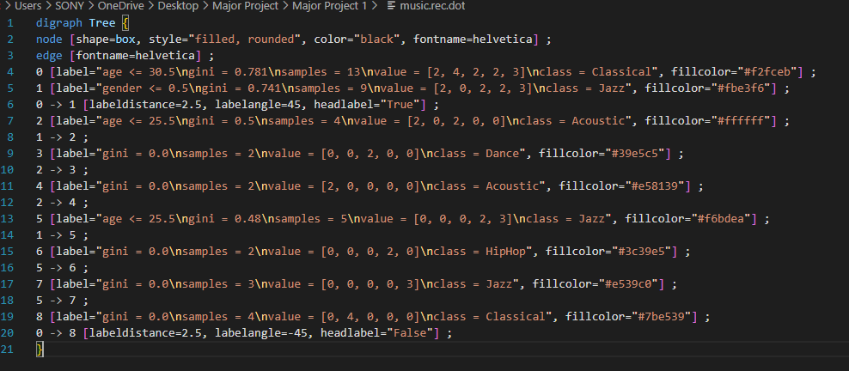

Output:

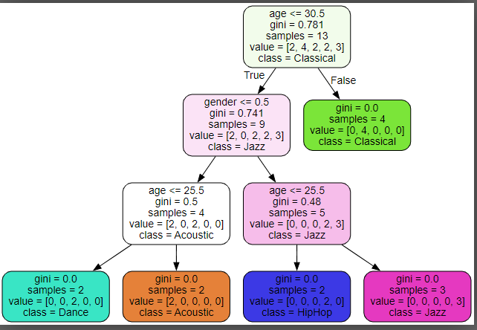

**MAJOR PROJECT 2**

Create any of the Image Processing Projects using NumPy and/or OpenCV. (Projects done in the class are not accepted)  
(One can use the haarcasacde models if necessary)

PROCEDURE:

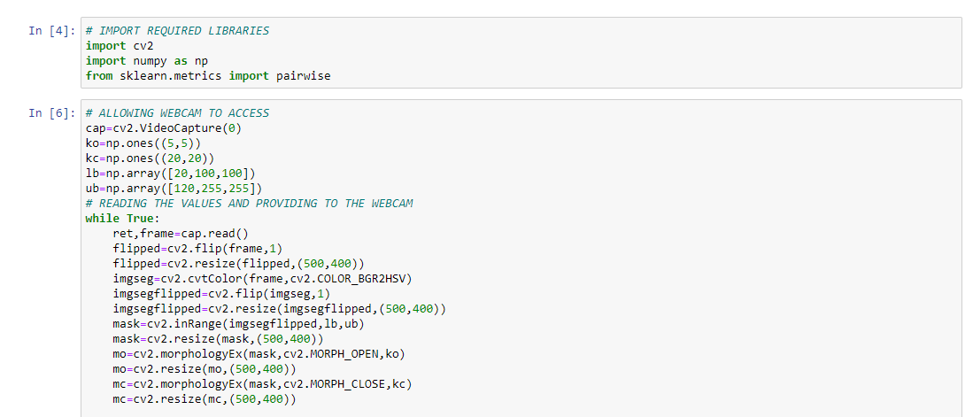

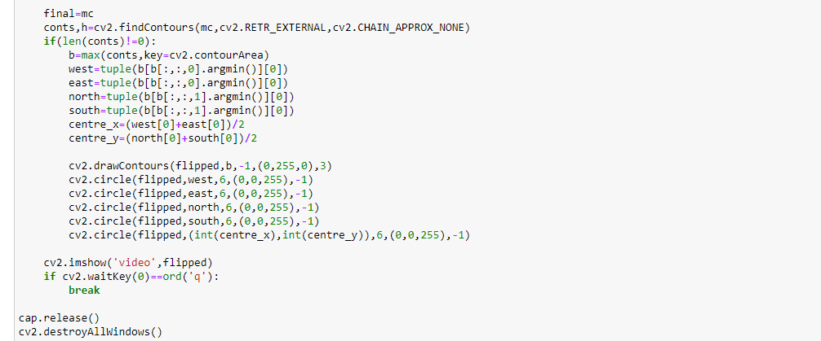

Output:

Live video

Github link: <https://github.com/kvsravan/MAJOR-PROJECT>

CONCLUSION:

Therefore, I have successfully executed both the programs and learned about the Decision Tree Classifier and Opencv